Staff Wireless Connection Instructions

There are a few wireless networks that are available to you. Connecting to either of these staff networks will provide you with internet access and access to our network servers/files/printers.

SLUSD-STAFF is the preferred network for staff use and the one you should try first if you are connecting with a Mac, iPhone, iPad or Windows 7.

For those staff members that are still using Windows XP, please connect to the SLUSD-Staff-WPA network (instructions below).

To Connect to the SLUSD-STAFF Network

When you first try to connect, you will see the following message:
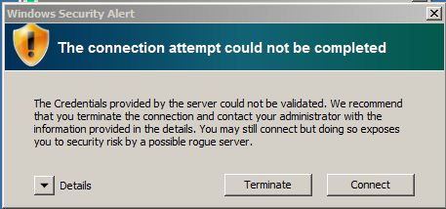

Click on “Connect” and you will be prompted to enter in your District username and password. The prompt will look like this:
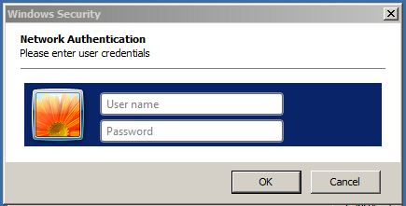

Once you enter your login information, you will see the following box again:

Once you click on “Connect” again, you will be connected.

To Connect to the SLUSD-Staff-WPA Network
(For Windows XP machines)

When you first connect, you will be prompted to enter in a network key. The network key is: sanleandro007 (You will only have to do this portion once as the computer will remember the password key the next time you logon.)

Then you have to open a web browser at which point you will get a login screen that looks like the following:
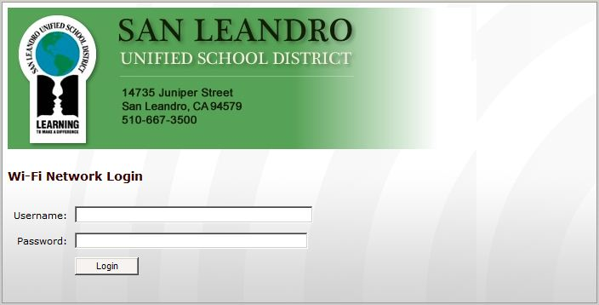

Here you will enter in your District username and password. After you login, you’re connected!

