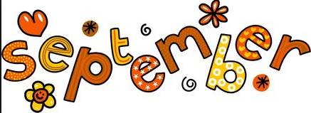

Room 9 Newsletter

Ms. Saucedo

September 15, 2016

We are a community of Scholars!

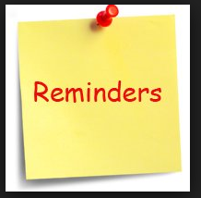

Please check your child’s homework and sign their homework agenda/log DAILY

**Book Fair:** Sept. 10-16

**Spelling Test:** Fri., 9/16

**Math Test:** Mon., 9/19

**Picture Day**: Weds., Oct. 5

**Map Project Due:** Fri., Oct. 14

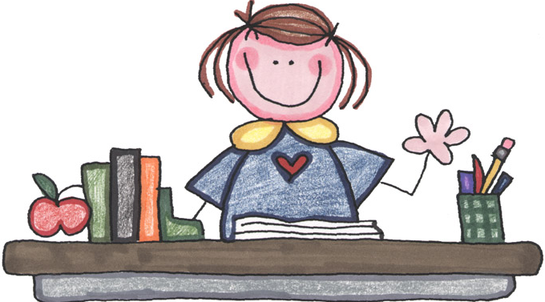 Teacher’s Corner

Dear Parents/Guardians:

Students have worked so hard, they filled up their first jar for a treat: popsicles! Next treat: donuts. Final treat: Pizza and a Movie!

Homework rewards: To celebrate our fruitful labors in completing homework assignments in a timely manner, Room 9 Scholars get to have Fun Friday afternoons (2:30ish). Last week we played kickball and we had a “kick.” ☺



SHOE BOXES! SHOE BOXES!

We will be working on an ecosystem project for science and your child will need to bring a box (no larger than 12 inches, please).

Janessa and Math are quickly becoming friends! Janessa is working hard to open her mind and heart to what Math has to offer. Keep trying, Janessa!

Plastic Bottles: Your child will need to bring an empty, small, and clean plastic bottle to plant seeds. NEED BY next Friday: Sept. 23.

Notebooks needed from the following students: 9, 15, 16, 20, 21, 25, 26

Birthday Celebrations

Please DO NOT send your child with sweet treats! We have MANY ants and I would hate for your treats to be spoiled. Also, PLEASE be courteous and let me know AHEAD of time if you plan on bringing treats so that I can plan my day/time for celebrating. Thank you.

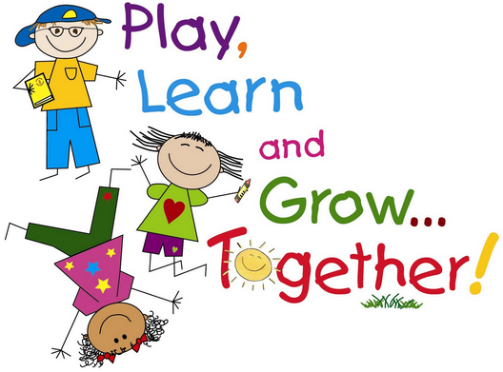



Room 9 Scholars are Learning

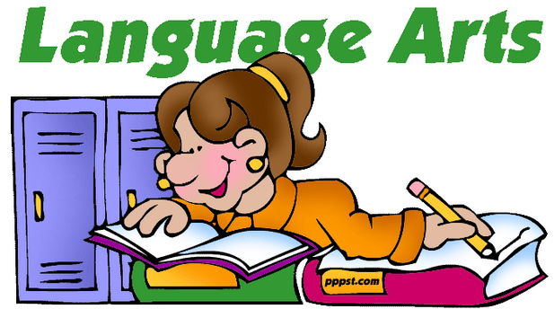

Story: Various

Genre: Informational Text

**Reading Comprehension Skill:**

**Reading Comprehension Strategy:**

**Grammar:** Types of Sentences

**Vocabulary**:

**Figurative Language**:

**Writing: Narratives**

Students are writing a variety of stories and poetry, too!

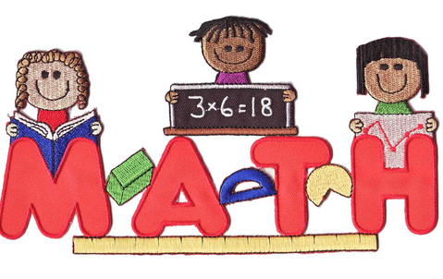**Use place value understanding and properties of operations to perform multi-digit arithmetic.**

[CCSS.MATH.CONTENT.4.NBT.B.4](http://www.corestandards.org/Math/Content/4/NBT/B/4/)

Review: Number and Operations in Base Tens (NOBT 2)

*Read and write multi-digit whole numbers using base-ten numerals, number names, and expanded form.

*Compare two multi-digit numbers based on meanings of the digits in each place, using >, =, and < symbols to record the results of comparisons.

*Round multi-digit numbers

Science

Theme: **Living and Nonliving Organisms are Interdependent**

?: How do organisms depend on each other?

**Vocabulary**: organisms, photosynthesis, roots, stem, leaves, stomata, carbon dioxide, oxygen, energy, glucose

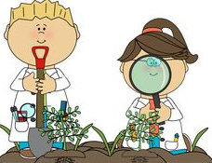

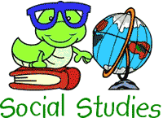

?: How can lines of latitude and longitude help us find a location?

Vocabulary: longitude, latitude, compass rose, cardinal directions, equator, prime meridian, absolute location.