Guest Wireless Connection Instructions

The SLUSD-Guest network will allow access to the internet but will prevent access to any of the internal resources such as Aeries, printers or files. This is the wireless network that all visitors to the district and non-employees should use.

To Connect to the SLUSD-Guest Network

Select the SLUSD-Guest network from your list of available networks. You may be warned that it is an open network and not password protected. This is not a problem and proceed with connecting.

Once you are connected, you will have to open a web browser at which point you will get a login screen that looks like the following:
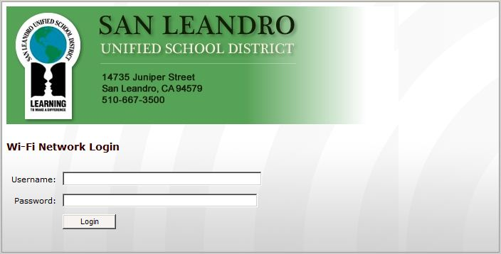

Here you will enter in a guest username and password to login.

The username to use is: slguest (all lower-case)

The password is: falcons (all lower-case)

This will be the generic password that anyone wishing to connect to the guest network can use.

