Dolphin News

1300 Williams St., San Leandro, CA 94577
510-618-4370
www.sanleandro.k12.ca.us
Virginia Quock, Principal
Maurice Gause, Vice Principal
February 2020

Important Dates to Remember
February
Feb 14 ELAC Meeting
Feb 17-21 President’s Week, No School
March
March 13 Report Cards Distributed
March 27 Staff Development Day, No School

** Every Wednesday Early Dismissal **
The California Healthy Kids Survey (CHKS) is an anonymous, confidential survey of school climate and safety, student wellness, and youth resiliency. Parents and families are invited to take the survey NOW ONLINE! You can take the survey on Wilson Elementary’s website https://www.sanleandro.k12.ca.us/wilson today! The link to the survey is on the homepage, in the top left hand corner. Click on the “Learn More” button to take the survey. 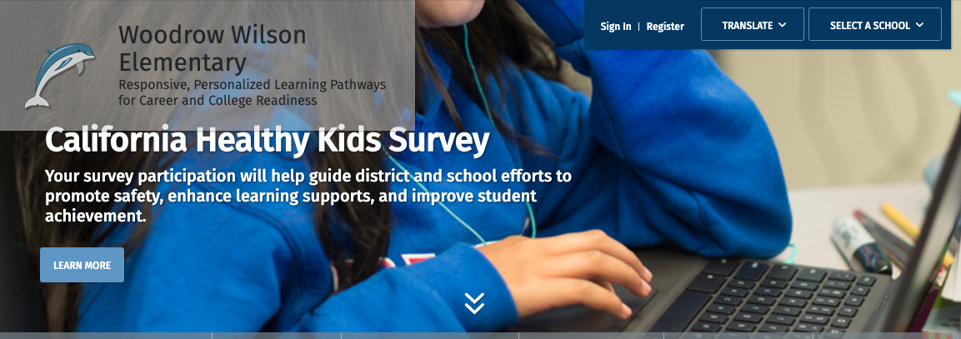
If you are not able to take the survey from home, Wilson’s Parent Facilitator, Angelica Franco, is available to assist in taking the survey online at Wilson. Please come to the Main Office for assistance.If you have any questions, please contact Principal Quock.

Nurse’s Notes-Your child will enjoy school and be better able to learn if s/he is well. It is important that children avoid unnecessary exposure to the many viruses that abound during the year. If your child becomes seriously ill, runs a high fever or you are concerned, please contact your doctor. Please keep your child home from school if s/he has one of the following symptoms:
A runny nose when the mucus is thick or colored
Severe congestion that interferes with breathing, or if wheezing
A rash
Fever of 100 degrees or more
Also, please keep them home for 24 hours after s/he has recovered from any of the following conditions
Vomiting or diarrhea
Elevated temperature, (child should be fever free, without needing fever reducing medication for 24 hours
Other obvious illness
But remember we lose funding every day your child misses-even if they are ill and bring a note! So please send your child to school if they do not fit into one of the categories listed above.

It’s time to order your yearbook! Yearbooks can be ordered online. Information about ordering was shared on Parent Square. Extra flyers are available in the Wilson office.

Dear Dolphin Families and Community,
Happy Year of the Rat! Thank you to the Wilson families who donated red envelopes and lucky money which made it possible for EVERY Wilson student to receive a good luck envelope for the Lunar New Year.
Thank you to families who helped us set out Black History Month gallery in the Main Entrance this week. Please take the time to read and appreciate the work and history that our students have created and collected to acknowledge and celebrate the contributions of African American people in our community and in the United States.
Do you have opinions on how the San Leandro Unified School District spends money but don’t know how to take action? Attend an upcoming Local Control Accountability Plan (LCAP) community forum to have your say! This year, in order to provide more opportunities for feedback, every school site will host at least two LCAP family engagement opportunities. These events will also include details about our facilities improvement bond, Measure N, which is on the ballot for March 3rd. Please join us at one or more of the events listed below. February 11, 6:00-7:30pm at Wilson Cafeteria-this event is for the Muir and Wilson communities! Come and meet the Muir Administration and families at this special evening event. If you are unable to attend the LCAP events at Wilson, SLUSD will also host community forums on the following dates:
February 25 at Bancroft Middle School from 6:30 to 8 pm, presented in Spanish
February 26 at John Muir Middle School from 6:30 tp 8 pm, presented in Chinese
February 29 at the Barbara Lee Center for Health and Wellness, 9:00-10:30 am, presented in English

Let’s make it a great February! Go Dolphins! With respect, Principal Quock
Mrs. Virginia Quock

