**Assignment: Make a Chinese Paper Lantern**

**Step 1:** Watch this video. [How to make a lantern](https://youtu.be/TQMhy3w_fXM)

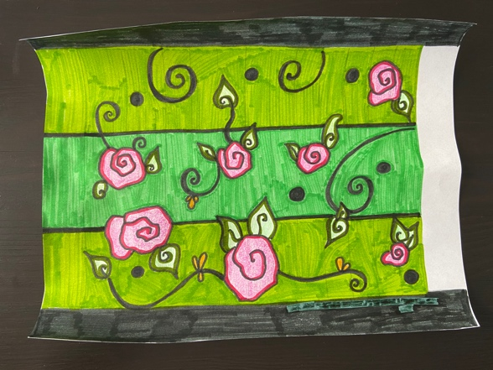

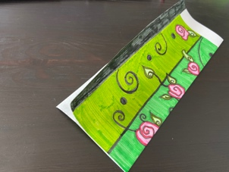**Step 2:** Start with the blank template provided at the bottom of this document. The dragon and cherry blossom template are examples, so make sure you use the blank one. Print it out or draw a similar one. Draw a detailed design using markers, sharpie, colored pencils, or whatever you have around your house. Traditionally, Chinese lanterns include drawings of fruits, flowers, birds, animals, people, and buildings. Make sure you decorate and add color. Take a picture of your finished drawing!

**Step 3:** Fold paper in half long ways (hotdog way).

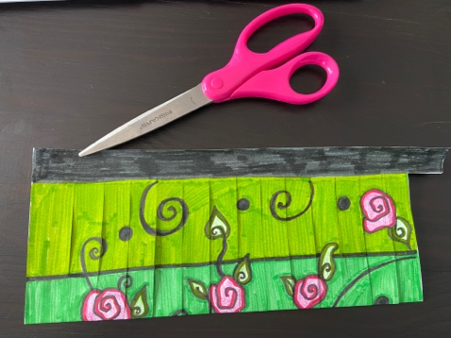

**Step 4:** Take your scissors and put them on the fold. Cut through both pieces of paper all the way to the edge of the line. Cut all lines. The last line to cut looks a little different, but instead of stopping at the top, you’re going to cut that whole tab off. These tabs will help you connect your lantern.

**Step 5:** Flip your lantern over (that’s the inside of your lantern) and print the smaller template (provided at the bottom of the document). It is intentionally smaller than the first template. Using a glue stick, glue the top and bottom edges by lining it up with the top of your lantern, and the bottom. This will make it three dimensional. Press it down until it sticks.

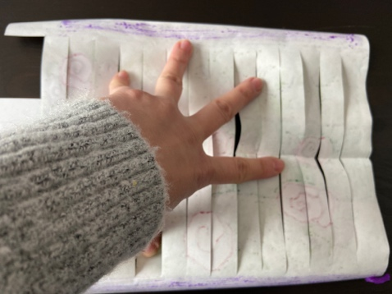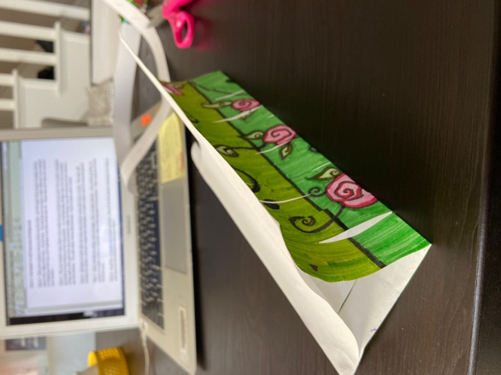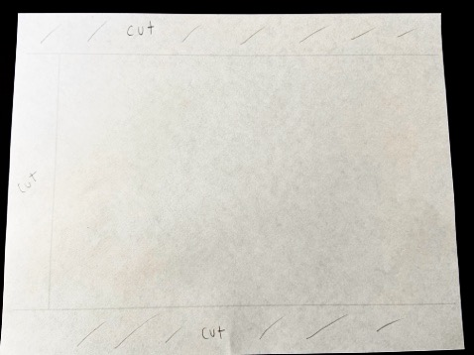

**Step 6:** Add glue to both tabs and take your lantern and roll it into a circle. The tabs will overlap the lantern, and put a paperclip clothespin, or hold it down until it’s securely glued. Tape the inside cylinder so it doesn’t have a gap.

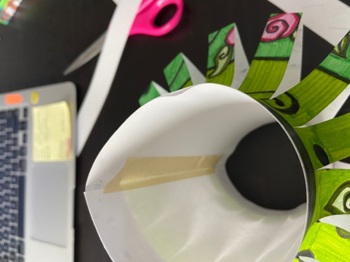

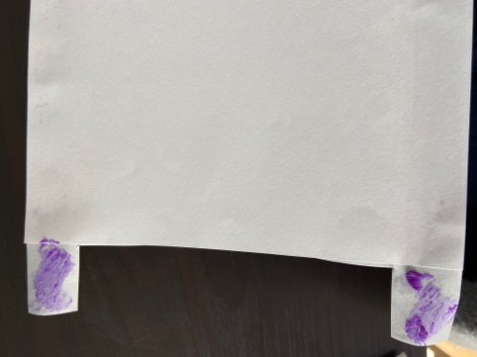

**Step 7:** Add a handle by using a strip of paper, yarn, or pipe cleaner. Use a hole puncher, or just glue on opposite sides of the top part of the lantern. Take a picture of your finished work.

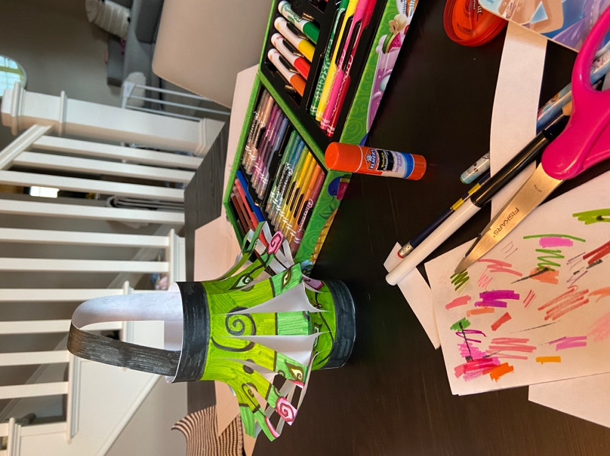

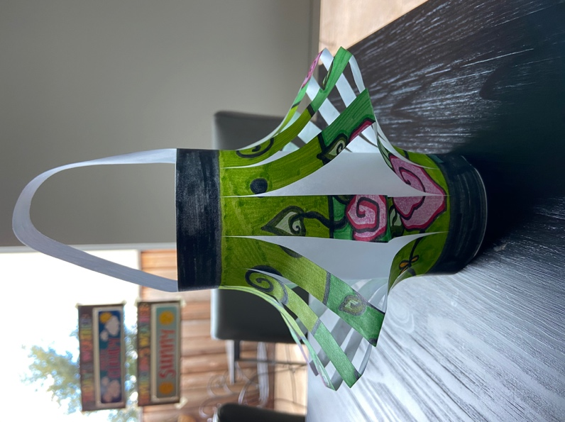**Step 8:** Email Ms. Lo [glo@slusd.us](mailto:glo@slusd.us) both pictures. One of the flat lantern drawing from Step 2, and one from the finished lantern from step 7.

THE END!



chinese%20lantern/Chinese%20Lantern%20Templates.pdf



