Summary of Historical Figures

Directions: Listed below are the historical figures that will take part in the press conference, along with a summary of the views of each on government. Use this information to help you prepare for the press conference. This should be especially helpful for the Historians and Investigative Reporters.

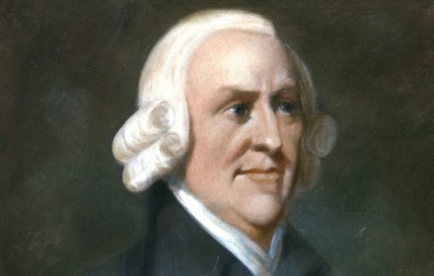 | Adam Smith (Capitalist) - Smith is often called the father of capitalism. He believed that people were driven by self-interest and greed. He believed, through competition, business would develop new technologies and better products sold at lower prices. Smith believed in Laissez-faire, or the concept of government non-involvement in economic and business affairs. Critics of capitalism point out that the workers who help innovate and create the products rarely receive proper compensation for their work and that the progress that they help create fails to benefit them.

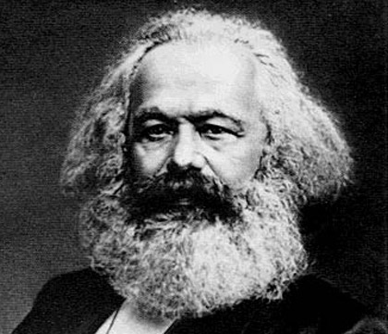 | Karl Marx (Communist)–

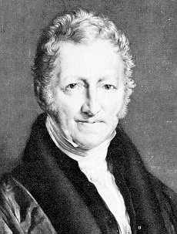 | Thomas Robert Malthus —  In his “Essay on the Principle of Population” Malthus insisted that the working man should blame himself - not the factory owner – for his poor living conditions. Working class families made the mistake of having more children than they can support, and are therefore responsible for their own poverty. Large families also are a cause of unemployment, as there are more job seekers than jobs

 | Robert Owen (Utopian Socialist)—  Owen believed that people brought up along lines of goodness and decency would turn out to be people of fine character. Owen purchased a mill where he employed workers under only the best conditions. In the mill town he improved housing, established low-priced stores, and founded schools.

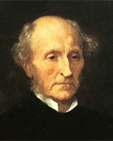 | John Stewart Mill (Democratic Liberal)— John Stuart Mill and other Democratic Liberals rejected the laissez-faire policies proposed by Capitalist Liberals. They urged government reforms to help workers who were suffering from abuses by factory workers. Democratic Liberals favored higher wages, a reduction in working hours, safer working conditions in factories, the formation of labor unions, and giving workers the right to vote.

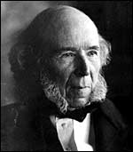 | Herbert Spencer (Social Darwinism)— Herbert Spencer (1820-1903) spent his early life working as a civil engineer for a railway company. In his 30’s he inherited a large amount of money and no longer needed to work for a living. He devoted his time to the study of society.  Spencer was influenced by the ideas of Charles Darwin, an evolutionist of the 1800’s. Spencer developed a model of society based on the biological idea of survival of the fittest. In biology an organism’s health is dependent on its ability to adapt and survive. Social change and unrest challenged individuals and groups to change behaviors to survive and succeed. Those that did advanced economically and socially, others fell behind. Spencer was optimistic that evolutionary processes would weed out weaker traits and reward socially responsible behavior. Darwin coined the phrase ‘survival of the fittest’ to describe why some animals succeeded in nature; Spencer used this to describe why some groups succeeded in human society. The basic concept of social Darwinism is that adaptation to new environments gives individuals a competitive advantage.
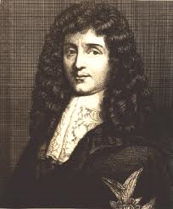 | Jean Baptiste Colbert (Mercantilism) — Controller General of Finance under Louis XIV of France. Believed in a system of Mercantilism where wealth was measured by the amount of Bullion (Gold, Silver and Trade Goods) that a nation had. In order to achieve this a nation must have a “favorable balance of trade” in which a nation would sell more than it purchased from other nations (Exports – Imports)
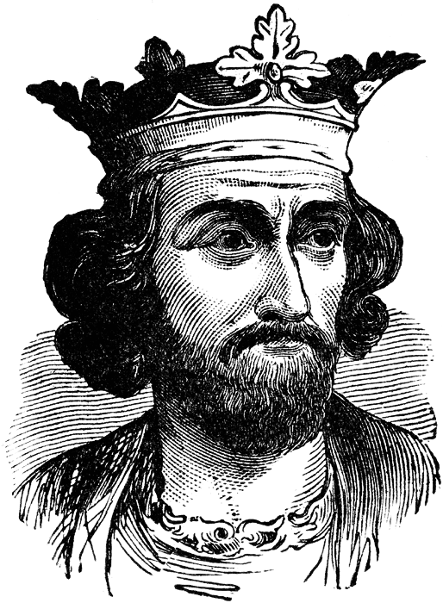 | Edward I (Feudalism/Manorialism) — King of England between1272-1307. Edward I lived during the era of feudalism in which power was held by a King and under the King served Lords and Vassals. A lord was a noble who owned land, a vassal was a person who was granted possession of the land by the lord, and the land was known as a fief. In exchange for the fief, the vassal would provide military, legal and economic service to the lord and King. The system was based on fealty (loyalty) to your superiors.

