Harriet Jacobs Owns Herself

For their first 246 years on this continent, African Americans were treated as possessions, not people. Although the Declaration of Independence declared all men equal, the United States Constitution defined a slave as equivalent to three-fifths of a free man. Slaves could not vote, own property or, in most cases, earn money. They had no right to an education. Many were not allowed to marry the person of their choice. The slave market often separated wives from husbands and parents from children.
Yet, even under these conditions, the strongest of human aspirations survived. The story of Harriet Jacobs reminds us of the multitude whose names are forgotten.

Harriet Jacobs had such a sheltered and carefree early childhood in Edenton, N.C., that she was 6 years old before she knew she was a slave. Harriet’s father, Daniel, was a carpenter who supported himself like a free man, although he had to pay his owner $200 a year for the privilege. Her grandmother, Molly Horniblow, earned good money selling her famous pastries to the women of Edenton.

Because the Jacobses belonged to a city family, they enjoyed more freedom of movement that plantation slaves. It was not until 1819, when her mother died, that Harriet learned she was someone else’s property.

Young Harriet knew her grandmother’s stories about being freed as a child and captured back into slavery, about later seeing each of her five children sold to a different master. But Harriet’s mistress taught her to read and write and sew and led her to believe that one day she should get her freedom. Then the mistress died. In her will, she left 11-year-old Harriet to a 3-year-old niece.

Harriet’s young owner was the daughter of Dr. and Mrs. Norcom, who had also bought Harriet’s younger brother, John, for their son. Slave life at the Norcoms’ was the nightmare that Harriet had only heard tales about until now. The first time Harriet wore some new winter shoes her grandmother had given her, Mrs. Norcom asked what was making such a horrible squeak.

“Take them off,” she said, “and if you put them on again, I’ll throw them into the fire.” After Harriet removed the shoes, Mrs. Norcom sent her on a long errand in the snow. That night Harriet’s throat was so sore that she thought she might die. In the morning, she was almost disappointed to find herself well again.

Harriet and John’s father died later that year. While his wake was taking place less than a mile away, Mrs. Norcom made Harriet stay and decorate the Norcom house for a party.

[“In the Night Season” (document): The personal activities of slaves were severely regulated. The General Court of Connecticut Colony enacted a law that reveals the fear with which slave owners regarded their human property.
Be it enacted by the Governour, Council and Representatives, in General Court assembled, and by the authority of the same, That from and after the publication of this act, if any negro or Indian servant or slave shall be found abroad from home in the night season, after nine of the clock, without special order from his or their master or mistress, it shall be lawful for any person or persons to apprehend and secure such negro or Indian servant or slave so offending, and him or them bring before the next assistant or justice of peace; which…shall have full power to…order him or them to be publickly whipt on his or their naked body, not exceeding ten stripes, and pay cost of court, except his or their master or mistress shall redeem them by paying a fine not exceeding twenty shillings.]

Grandmother Molly grieved to see the children mistreated. She saved every penny she could in the hope of some day being able to purchase her entire family. In the meantime, whenever Harriet passed by her grandmother’s place, Molly secretly handed her a treat—Mrs. Norcom didn’t allow the girl to stop for visits.

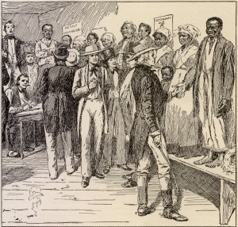  A slave auction |  | Molly’s mistress—Mrs. Norcom’s mother—had always promised to free Molly in her will. But when the old lady died, Dr. Norcom decided that Molly had to be sold instead. Molly’s many white friends in Edenton were horrified when she stepped up, straight and calm, onto the auction block. For a long time, no one offered a bid. Then a woman called out, “Fifty dollars.” It was the dead mistress’s maiden sister, who knew Molly well. The sister couldn’t read or write, but she marked an ‘X’ on the bill of sale and then gave Molly her freedom.  Dr. Norcom frequently received high offers for Harriet, but he turned them all down. In public, he said that she wasn’t his, but his
daughter’s. In private, however, he followed a different policy. When Harriet was 15, the 50-year-old Dr. Norcom raped her. The attacks continued, and Norcom swore he would kill her if she didn’t remain “silent as the grave.”

Harriet knew of at least 11 slave children that Dr. Norcom had fathered. She had seen him sell them and their mothers away. But Dr. Norcom refused to let Harriet go. When she fell in love with a young freeborn carpenter in the neighborhood, Norcom ordered her never again to speak the man’s name. He said that if the suitor came back to see her he would “shoot him as soon as I would a dog.” Reluctantly, Harriet broke off the relationship.

Dr. Norcom’s behavior was no secret to his neighbors. Samuel Sawyer, a prominent citizen and a bachelor, took an interest in Harriet’s plight, and the two soon developed a mutual affection. Harriet knew that her relationship with a white man of her own choosing would enrage Norcom. In fact, she hoped it would. She was now more determined than ever to repel her master’s advances.

Norcom did become furious, but he rejected Sawyer’s offer to buy Harriet. When Harriet’s affair with Sawyer produced a son, the doctor reminded the new mother that any child of hers belonged to him. Harriet gave birth at her grandmother’s and stayed on there with her baby, Joseph. Norcom’s wife threatened to kill Harriet if Norcom brought her back to their home.

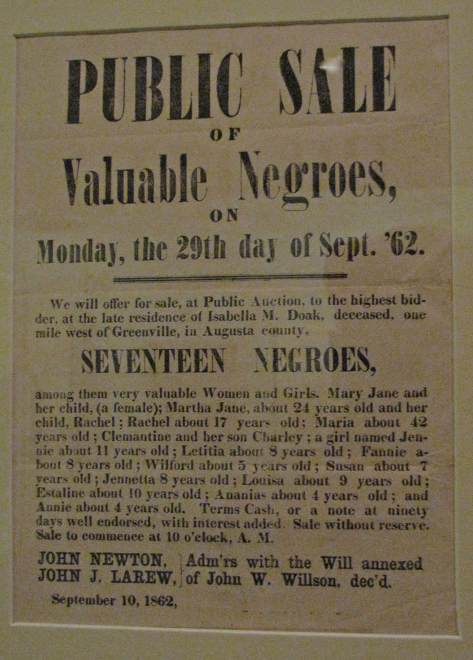  Announcement of a slave auction |  | Molly’s house was like a peaceful island in a troubled sea. Her pastry business supported the family in modest comfort. Here Harriet watched little Joseph grow and prayed for his freedom. Yet, across the South, conditions were worsening for slaves. In 1830, North Carolina made it a crime, punishable by 39 lashes, to teach a slave how to read. The next year, slaves were forbidden to gather for prayer meetings. Slave owners were so fearful of an uprising that they even attempted to deny slaves the refuge of religion.  In late August 1831, the slave owners’ worst fear came true. Forty miles north of Edenton, in Southampton County, Va., a slave preacher named Nat Turner led a revolt that left 55 white people dead. The incident sent a wave of terror over the whole region.  In Edenton, angry whites shouldered their rifles and marched through town. Among
these were many who were too poor to own slaves but who enjoyed having a “lower” group to look down on and took special pleasure in this opportunity to harass blacks. Many slave women and children hid in the woods and swamps while their cabins were searched and ransacked. Any suspicious document or trace of ammunition—including items planted by the searchers—could be considered proof of a “plot.

The ruffians searching Harriet’s grandmother’s house found a trunk packed with fine linens that she had bought and cared for over the years. When the men asked Molly where a “nigger” stole such things, she said certainly not from any of their houses. One fellow hooted and waved some papers he’d found. The leader of the group took the sheaf and began reading out loud—fancy poetry! The disappointed hoodlums raided Molly’s jelly cupboard for a taste from each jar before going out to trample her garden.

Nat Turner eluded his pursuers for more than two months. Following his widely publicized capture, torture, trial and execution, white outrage subsided somewhat, although daily patrols continued in some districts. It now occurred to local planters that a little religion among the slaves might not be such a bad idea—it might, in fact, keep them from murdering their owners! Local churches began holding special slave services. “If you disobey your earthly master,” white preachers warned, “you offend your Heavenly Master.”

Molly and Harriet believed that good would eventually overcome the evil of slavery. But Dr. Norcom once again put their faith to the test. He seemed to them to be the Devil on earth. When he learned that Harriet was expecting another child by Mr. Sawyer, he came and chopped off all her hair with rough shears. The birth of a daughter made Harriet grieve—she knew that slavery was even harder for women than it was for men.

While the little girl, Louisa, was still a baby, Harriet arranged to have her and Joseph baptized. The former owner of Harriet’s father invited the family to her house after the ceremony. The old woman brought out a tiny gold chain and fastened it around Louisa’s neck. Harriet expressed her gratitude but said that she could abide no chain on her daughter, not even one of pure gold.

More than anything, Harriet longed to escape with her children from bondage. One day Dr. Norcom proposed a single condition for their freedom—that Harriet cease all contact with Sawyer. She didn’t believe him for a minute. She knew it was another trick. If any white man was going to help her, it was Sawyer. When she refused Norcom’s offer, he ordered the three of them sent to his son’s plantation, six miles outside of town.

Six-year-old Joseph was sick on the appointed day, so Harriet and Louisa left him at Molly’s. Young Norcom put Harriet to work immediately, repairing the house for his new bride. Louisa, age 3, spent her long, solitary days crying. One morning she crawled up under the big house and cried herself sick. As Harriet was pulling her out, young Norcom appeared, frowning, and then walked away. The next day, he let Harriet send Louisa back to town in a cart loaded with shingles.

[A Slave Auction (first person): Solomon Northup, born in 1808 to free black parents in Minerva, N.Y., was kidnapped into slavery while on a visit to Washington at the age of 33. He endured 12 years of bondage in Louisiana before New York State officials, along with Solomon’s wife, helped win his freedom. He published a memoir of this period, Twelve Years A Slave, in 1853. The following excerpt describes a New Orleans slave auction:
Mr. Theophilus Freeman bustled about in a very industrious manner, getting his property ready for the sales-room, intending, no doubt, to do that day a rousing business.
In the first place we were required to wash thoroughly, and those with beards, to shave. We were then furnished with a new suit each, cheap, but clean. The men had hat, coat, shirt, pants and shoes; the women frocks of calico, and handkerchiefs to bind about their heads….
The men were arranged on one side of the room, the women on the other. The tallest was placed at the head of the row, then the next tallest, and so on in the order of their respective heights….
He would make us hold up our heads, walk briskly back and forth, while customers would feel of our hands and arms and bodies, turn us about, ask us what we could do, make us open our mouths and show our teeth, precisely as a jockey examines a horse which he is about to barter for or purchase.
During the day…a number of sales were made….Lethe was sold to a planter of Baton Rouge, her eyes flashing with anger as she was led away.
The same man also purchased Randall. The little fellow was made to jump, and run across the floor, and perform many other feats, exhibiting his activity and condition. All the time the trade was going on, Eliza was crying aloud, and wringing her hands. She besought the man not to buy (her son), unless he also bought herself and Emily (her daughter). She promised, in that case, to be the most faithful slave that ever lived.
The man answered that he could not afford it, and then Eliza burst into…grief, weeping plaintively. Freeman turned round to her, savagely, with his whip in his uplifted hand, ordering her to stop her noise, or he would flog her. He would not have such work—such sniveling; and unless she ceased that minute, he would take her to the yard and give her a hundred lashes.]

All alone now, Harriet missed the smiles of her children, the strength and consolation of her grandmother. She had to get used to the roughness of plantation life. One Monday evening she watched as the foremen of the field hands passed out weekly rations of smoked meat, herring and corn. An old slave who had served three generations of Norcoms waited in the line. Harriet heard the mistress—Norcom’s new wife—tell the foreman the man didn’t deserve a ration. She said that when a slave got too old to work, he “ought to be fed on grass.”

Harriet went about her assigned duties but kept her mind on one thing: escape. After her master offered to let her move from the cramped slave quarters into the big house, she found her opportunity. One dark rainy midnight she jumped out a window and ran off the plantation unobserved.

She stopped by Molly’s without waking her and looked in on the children. She stayed a few nights at a friend’s house, then fled from a search party and spent a week in a thicket. A snakebite forced her back into town, where an old woman saved her life by drawing the poison out with copper pennies steeped in vinegar. A slave-owning woman friend of Molly’s offered a place to hide—under a floorboard in her kitchen. The woman’s cook helped Harriet into the hole and covered her with a quilt. Then she laid a buffalo skin over the plank. All day |  | 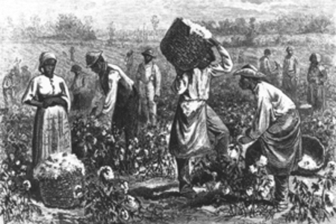  Field slaves
long, the cook “talked to herself” to keep the runaway from getting lonely.

Dr. Norcom first offered a $100 reward for Harriet’s capture. Then he placed her young children, along with her brother John and her Aunt Betty, in jail at his own expense to force them to reveal her hiding place. They remained silent. Six-year-old Joe made a new mark on his cell door every day.

The talk around Edenton was that Harriet had fled to New York. Dr. Norcom believed this and went looking for her. Sawyer reasoned that the cost of such a trip, along with that of holding the prisoners, might make the doctor willing to consider a sale. Sawyer arranged to buy John, Joe and Louisa. The day they got out, Joe counted 60 marks on the door.

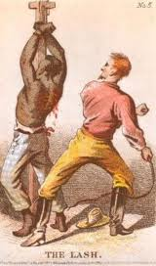  Whipping of a slave |  | Harriet rejoiced to hear the news. She knew that very soon Sawyer would free the children as he had promised. Her friends and loved ones now set Harriet on a new plan. They decided it wasn’t safe for her to remain where she was. The cook brought her a sailor suit and a small bundle of supplies.  “Put your hands in your pockets,” the cook said, “and walk rickety, like the sailors.” This wasn’t hard to do, after weeks of lying under a cold floor!  The plan was for Harriet to hide out on a boat on Albemarle Sound while Uncle Joe made other arrangements. When the boat became too risky, her uncle’s friend Peter hacked out a den for her in a bamboo swamp. There were snakes all around, and the tobacco that Peter burned to keep away mosquitoes gave Harriet a headache. She was grateful that the snakes, at least, refrained from biting.

It thrilled Harriet to learn that the place Uncle Joe had prepared for her was back at her grandmother’s. Mr. Sawyer had sent the children to live there. She couldn’t wait to see them again. She knew there was danger involved—as there was in everything she did now—but she never imagined the difficulties.

Her new dwelling was a cramped attic above a storage shed on Molly’s patio. It had no windows or air vents—only a trapdoor. The total darkness meant that rats and mice crawled around her constantly. Roaches and spiders were her other companions. Molly or Uncle Joe or Aunt Betty slipped food and whispered encouragement through the trapdoor at night, but it wasn’t safe to tell the children where she was. Harriet could only listen when they played nearby. One day she found a small drill that Uncle Joe had forgotten and made a peephole that let her catch glimpses of them.

Gradually, Harriet’s eyes grew accustomed to the dark. She even managed to read and sew. Time seemed as tedious and burdensome as her own movements—the ceiling was so low that, for exercise, all she could do was crawl. No one knew how long she would have to stay there. Season gave way to season. At first, the heat of late summer made sap drip from the roof shingles. Autumn was mild, but the winter chill cut like a knife.

For Christmas, she made Joe and Louisa each a new outfit with material that Molly brought her. On Christmas morning, she overheard some of the older children saying that Santa Claus was really their own mothers. Joe told them that this was impossible: His mother was up north in New York, but his stocking had been filled.

To Harriet’s outrage, Dr. Norcom continued to badger Molly. He bluffed that he knew where the escapee was and would soon have her. With the help of Uncle Joe and his friend Peter, Harriet arranged to have some letters sent to New York to be mailed back to Edenton. In them, she wrote to Dr. Norcom and to Molly that she was moving on to Boston, where the Abolitionist movement was strong. Dr. Norcom believed what he read.

Despite numerous promises, Sawyer still had not freed the children. He decided that Louisa should be sent to live in Brooklyn with his cousin, who had a little girl. Harriet feared that her daughter was being sent as a servant, but she was powerless to halt the plan. Even Mrs. Norcom objected, on the grounds that her daughter have never signed Louisa’s bill of sale. According to Aunt Betty, the Norcoms’ cook, Mrs. Norcom said that when Louisa left it was as if Mr. Sawyer had walked into her parlor and stolen a piece of furniture.

Aunt Betty was Harriet’s main link to the outside world. And it was Aunt Betty, more than anyone, who urged Harriet to take her chance at freedom. On the first day of January 1842—the seventh New Year’s that Harriet had passed in the attic—Aunt Betty came with some news. That morning their neighbor Fanny had been sold at the annual New Year’s auction. As her purchasers were taking her to her new home, Fanny escaped. Harriet felt the same excitement Aunt Betty did. They prayed that Fanny would make it and that Harriet’s turn would be next.

A few days later, little Joe reported to Molly that he had caught sight of Fanny in her mother’s house, right next door. Molly made him promise not to tell anyone else, but she did tell Harriet. It made Harriet both sad and hopeful to think of another fugitive so close by.

Aunt Betty took ill and died later than year, before Harriet could make their dream come true. Mrs. Norcom told the preacher that she wanted her faithful cook buried in the Norcom family cemetery. Molly, who was Betty’s mother, thanked Mrs. Norcom just the same but had the grave dug in the slave burial grounds. Uncle Joe paid for an elaborate funeral for his sister, though Molly knew that most of Edenton assumed the Norcoms had done it all.

With Aunt Betty gone, Harriet had no one to talk with about her schemes. But she was determined to find a way north. Uncle Joe’s friend Peter knocked on the trapdoor one night to tell her he’d found a captain who would take her. Molly cried when she heard it, knowing there was no changing the girl’s mind.

On the date Harriet was to leave, Peter informed her that the ship had been delayed. Harriet had spent seven years in the attic, but now she wasn’t sure she could stand it for one more minute. Then word came that another fugitive slave had been brutally murdered. Molly talked Harriet out of going at such a treacherous time. A spell of bad weather kept the ship in harbor.

[Closed Doors (document): Before the Emancipation Proclamation, many of the states in which slavery was illegal nonetheless placed harsh restrictions on African Americans. According to the 1851 constitution of Indiana, only “white male citizens” were allowed to vote. Further, the document specified, “No negro or mulatto shall have the right of suffrage.” Other provisions defined the status of blacks more fully.
ART. XII., SEC. 1. The militia shall consist of all able-bodied white male persons….
ART. XIII., SEC. 1. No negro or mulatto shall come into or settle in the State after the adoption of this Constitution.
SEC.2. All contracts made with any negro or mulatto coming into the State contrary to the foregoing section shall be void; and any person who shall employ such negro or mulatto or encourage him to remain in the State shall be fined not less than ten, nor more than five hundred dollars.]

Molly feared that the whole plan had fallen apart now, that they would all be found out. One morning she helped Harriet climb down to discuss the matter and forgot to lock the storeroom door. A housemaid called for Molly from the patio and barged in just as Harriet was darting behind some barrels. The maid said nothing, but Molly felt certain the secret was out. She had no choice now but to give Harriet her blessing, along with some travel money.

Molly brought little Joe, 12 years old now, to see his mother. He wasn’t even surprised. Several years before, he said, he had heard her cough overhead. He figured out that she was hiding there and that if he told anyone about it she might die. Harriet told him that as soon as she got her own freedom, she’d start working for his.

Peter led Harriet to the small boat that would take her to the big one. The captain welcomed her and showed her to her tiny room. There sat Fanny, who thought she must be seeing a ghost. The two friends hugged for a long time and cried. They knew all to well the world they were leaving. They could only dream of the one that lay ahead. They listened to the great timbered hull cutting the water—nothing but water between them and Philadelphia.

When she arrived in the North, Harriet realized her adventures had just begun. Her first task was to reunite her family. She learned that Mr. Sawyer had transferred ownership of Joe and Louisa to Molly, who was a free woman. Harriet instructed Molly to send Joe north and then brought Louisa there herself.

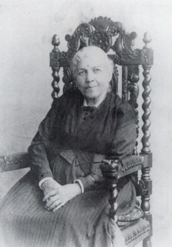  Harriet Jacobs |  | Three times Harriet eluded capture by slavecatchers before a woman she worked for arranged to buy her and officially set her free. Encouraged by her brother John, who was gaining a reputation as a lecturer in abolitionist circles, Harriet offered her talents to the organized antislavery movement.  Her new friends urged her to write and publish the story of her experiences in bondage. In 1861, a Boston firm issued the first printing of incidents in the Life of a Slave Girl, Harriet Jacobs’ autobiography. The book was published in England the following year. During and after the Civil War, Harriet worked in the Quaker relief effort in Virginia and Georgia, distributing clothes and seeds, teaching, and caring for the sick and wounded. For a time, she operated a boardinghouse in Cambridge, Mass. In 1896, Harriet’s daughter, Louisa Matilda, was one of the organizers of the National Association of Colored Women.
Harriet Jacobs died on March 7, 1897, in Washington, D.C. She is buried near her brother John in Mount Auburn Cemetery, Cambridge.

[Jim Crow is Watching (in context):
At the end of the Civil War, the 13th Constitutional Amendment outlawed slavery. In the next few years, the 14th and 15th amendments guaranteed African Americans the full rights of citizenship. The decade of Reconstruction brought blacks into public life and public office across the South. Still, even a bloody defeat on the battlefield and the long arm of Congress couldn’t loosen the grip of white power for very long.
By 1877, corrupt politicians and racist organizations like the Ku Klux Klan had begun to intimidate blacks into surrendering their hard-won equality. Lynch mobs carried out a bloody campaign of vigilante justice. Whites regained their former domination of local and state governments. They began passing laws that openly favored whites and redefined blacks as second-class citizens. The segregation laws acquired the name “Jim Crow” from a popular blackface minstrel song.
A rigid barrier between the races was enforced by separate schools, restrooms, waiting rooms, drinking fountains and seating areas in movie theaters and on trains and buses. Commercial facilities such as restaurants and laundromats could refuse service to blacks altogether. In addition, poll taxes and other measures limited black participation in elections. By denying African Americans educational, economic and political opportunities, these laws instituted a social system that was closer to slavery than to true freedom.

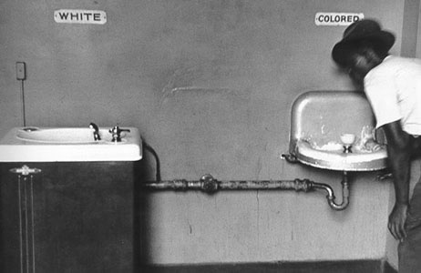 |  | 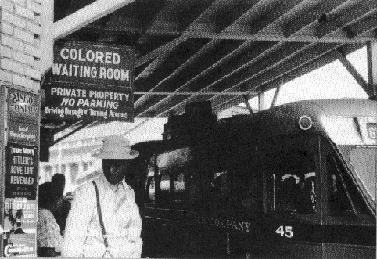
The Jim Crow system survived a serious legal challenge in 1896. In the case of Plessy v. Ferguson, the U.S. Supreme Court approved the use of separate facilities as long as they were equal. In practice, of course, the facilities were rarely equal. It would take another 60 years, however, for the courts to declare separate facilities inherently unequal. Anti-lynching campaigns and other national movements in the early 1900s focused national attention on injustices in the South. But not until the civil rights movement of the late 1950s was the Jim Crow system dismantled and replaced with fair and impartial laws.

The following are some examples of Jim Crow laws and provisions:
- That if any Negro, mulatto, or other person of color shall intrude himself into…any railroad car or other public vehicle set apart for the exclusive accommodation of white people, he shall be deemed guilty of a misdemeanor and, upon conviction, shall be sentenced to stand in pillory for one hour, or be whipped, not exceeding thirty-nine stripes, or both, at the discretion of the jury. (Florida, 1865)
- No property in a white section should ever be sold, rented, advertised, or offered to colored people. (Code of Ethics, Real Estate Board of Washington, D.C. 1948)
- It shall be unlawful for any person, firm, or corporation engaged in the business of cotton textile manufacturing in this state to allow or permit operatives, help and labor of the different races to labor and work together within the same room, or to use the same doors of entrance and exit at the same time,…or to use the same stairway and windows at the same time, or to use at any time the same lavatories, toilets, drinking-water buckets, pails, cups, dippers, or glasses. (South Carolina, 1950s)
- It shall be unlawful for white and colored persons to play together…in any game of cards, dice, dominoes, checkers, pool, billiards, softball, basketball, football, golf, track, and at swimming pools or in any athletic contest. (Montgomery, Ala., 1958)

