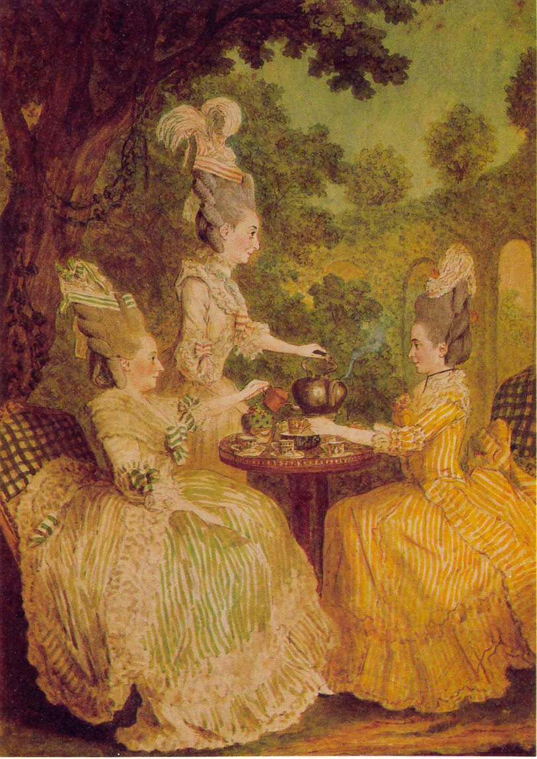
High Fashion in France

Lesson Suggestions

About the Transparency This watercolor depicts a fashionable French tea party of 1773. The artist, Louis de Carmontelle, shows us that that eighteenth-century French hairstyles reached heights unmatched by even the stiffly sprayed beehives of the 1950’s and 1600’s.
Two-foot-high hairstyles like those in the picture often contained false hair as well as the wearer’s natural hair. These tresses were elaborately arranged over a horsehair pad and anchored in place with pins. The eighteenth-century version of styling gel, a greasy pomade made of beef marrow, also helped keep the hair stiffly arranged. The whole structure was whitened with a shower of powder.
The headdresses topping off these hairstyles were as ornate as the hairstyles themselves. The ladies in this illustration wear poufs of ribbons, feathers, fabric, and lace on top of their hair. Some women adorned their hair with even more exotic creations, such as a small model of a sailing ship, a hunting scene, a miniature country landscaped complete with tiny ducks, or even a water-filled vase of fresh American battle of Bunker Hill-a political statement akin to wearing a political button today.
Needless to say, these hairstyles created certain inconveniences. When riding in their carriages, fashionable women had to kneel on the carriage floor and hang their heads out the window. Such expensive and time-consuming hairdos wee not redone often-sometimes only once a month. The infrequently-tended nests of hair could harbor bugs or even mice. Long, elegant ivory head-scratchers became, for the truly fashionable French lady, a crucial accessory.
You might introduce this transparency during a discussion of pre-Revolutionary France and the excesses of life at Versailles.

1. Class Activity Have students discuss what twentieth-century styles might seem as
absurd and inconvenient to people of other cultures as eighteenth-century French
hairstyles seem to us today. Do students ever wear anything uncomfortable just
because it is fashionable.
Background Students might consider such fashions as high-heeled shoes, tight jeans,
Mohawk haircuts, and punk hairdos dyed shades like pink and purple.

2. Writing to Learn Ask students to think about what other activities, besides traveling
might have been difficult or uncomfortable for the fashionable eighteenth-century
French lady. Have them imagine they are one of these ladies and write a humorous
description of the problems of a typical day. Tell students to revise their descriptions
for clarity, chronological order, and humorous effect before proofreading and making
a final copy.
Background to Learn Good papers will include specific facts, both observed from the
picture and learned in class, that are combined with imaginative details and perhaps
some exaggeration for comic effect. Some difficult situations might include taking a
nap or getting caught in the rain. Check to be sure students write in the first person
throughout.

