Ghost Dance at Wounded Knee

The massive Indian removals of the 1830s marked the end of the first phase of Indian conquest. Later, as the United States set its sights across the entire continent, there was no “outside” land to which Indians could be banished. Instead, the tribes were corralled inside the fixed borders of reservations—mostly barren patches of land that the whites hadn’t yet found a use for. While the Civil War was raging over the destiny of the slaves, the Indian Wars signaled the fate of another people. The contest reached its costly climax in 1890, on a South Dakota Sioux reservation called Pine Ridge.

One day when he was 14, a boy named Slow followed his father and some other Hunkpapa Sioux warriors on a raid against the neighboring Crow people. This was around 1845, in what is now South Dakota. The boy carried only a stick in his hand, but he rode straight toward a Crow warrior who was aiming an arrow at him and knocked the warrior to the ground.

For Slow’s bravery, his father gave him a new name: Tatanka Yotanka, or Sitting Bull, after the solitary buffalo that came to the father one night as a sign. Sitting Bull earned membership in the elite Strong Heart Society of warriors before he turned 17. He later became the society’s leader.

Sitting Bull came of age during a time of sweeping change for his people. Gathering on the horizon was an enemy much more powerful than the Crows. The U.S. government was starting to view the Great Plains as more than just a dumping ground for the eastern Indians. California gold fever brought herds of fortune-seekers over the grasslands. Railroads followed, sprouting supply depots and settlements along the way. Now the Plains tribes saw their worlds shifting and shrinking as the worlds of the Choctaws and the Cherokees and others had two decades before. The government’s policy toward the Indians amounted to a war strategy: Divide and conquer.

Sitting Bull was determined to resist. In 1868, he led a group of Sioux who refused to sign a treaty confining the tribe to a reservation. He knew that such treaties had often been broken, and he also knew that, within such narrow boundaries, his people’s way of life would end. Sitting Bull’s defiance inspired thousands of Indians from many Plains tribes to join the cause.

It wasn’t long before the Army, fulfilling the Indians’ worse fears, violated the Sioux treaty to prospect for gold in the Black Hills. Lt. Col. George Armstrong Custer was the leader of this expedition. In 1876, after the Sioux refused to sell the Black Hills, the government launched attacks against Sitting Bull’s branch and declared all of the reservation-dwellers prisoners of war.

On June 17 of that year, Sitting Bull, Crazy Horse and other fugitive Sioux surprised an Army unit at Rosebud Creek in southeastern Montana and forced it to retreat. Not far to the west, along Little Bighorn River, the victorious Indians stopped to hunt awhile and rest their horses. Here Sitting Bull performed the Sun Dance, a special ritual for bringing on visions. Afterwards he described what he had seen: government soldiers dropping out of the sky like grasshoppers.

The following week, Custer’s 7th Cavalry approached the sprawling riverside camp. No one knows why the commander ordered his men to charge the Indians before the expected reinforcements arrived. Of more than 200 U.S. troops and their mounts, only one horse, named Comanche, survived the resulting slaughter. The incident lent a bitter flavor to the nation’s centennial celebrations on July 4.

Sitting Bull’s legions knew that they would pay for the blow they had dealt the Army. The gathered tribes went their separate ways, some onto the open plains, others onto reservations. Sitting Bull kept his faith that the Indians could hold out against the white man’s greed. Meanwhile, the government forcibly “purchased” nine million acres from the reservation Sioux.

For five more years, Sitting Bull and his people wandered in the wilderness, resisting U.S. demands for their surrender. They sought refuge in Canada but finally, on the promise of a pardon for their leader, turned themselves in at Fort Buford, Dakota Territory, on July 19, 1881. The government agents broke their word and arrested Sitting Bull. He was held in military prison for two years before being released into the custody of Interior Department agents at Standing Rock Reservation.

Through vivid, often exaggerated newspaper accounts, Sitting Bull’s exploits had brought him international fame. The government arranged public appearances for the captive chief in 15 U.S. cities during 1884. The following year, he joined Buffalo Bill Cody’s traveling Wild West Show.

[Buffalo Bill and Sitting Bull (in context)
Like Sitting Bull, William F. Cody demonstrated his bravery and skill as a warrior early in life. He learned to wrangle horses and fight Indians as a boy in Kansas. During the Civil War, he served as a teenage scout for the 9th Kansas Cavalry in its campaigns against the Comanches and Kiowas.
When the Union Pacific Railway began laying its tracks across the continent, Cody found work as a buffalo hunter supplying the huge construction crews with meat. He earned his nickname by reportedly killing 4,280 of the animals in an eight-month stretch.  At the time the Civil War ended, the buffalo on the Plains numbered around 12 million. To the 31 Indian tribes of the region, these animals were a sacred gift of food, clothing and shelter. The white man saw them differently.  Professional marksmen like Buffalo Bill were followed by tourists who fired on grazing herds for sport. The discovery of a commercial process for making buffalo leather spurred the slaughter of more than 9 million head in the early 1870s. By the turn of the century, the entire buffalo population of the U.S. would be slashed to fewer than 50.  While Sitting Bull (named for a buffalo) was fighting for the rights of his people to live as they always |  | 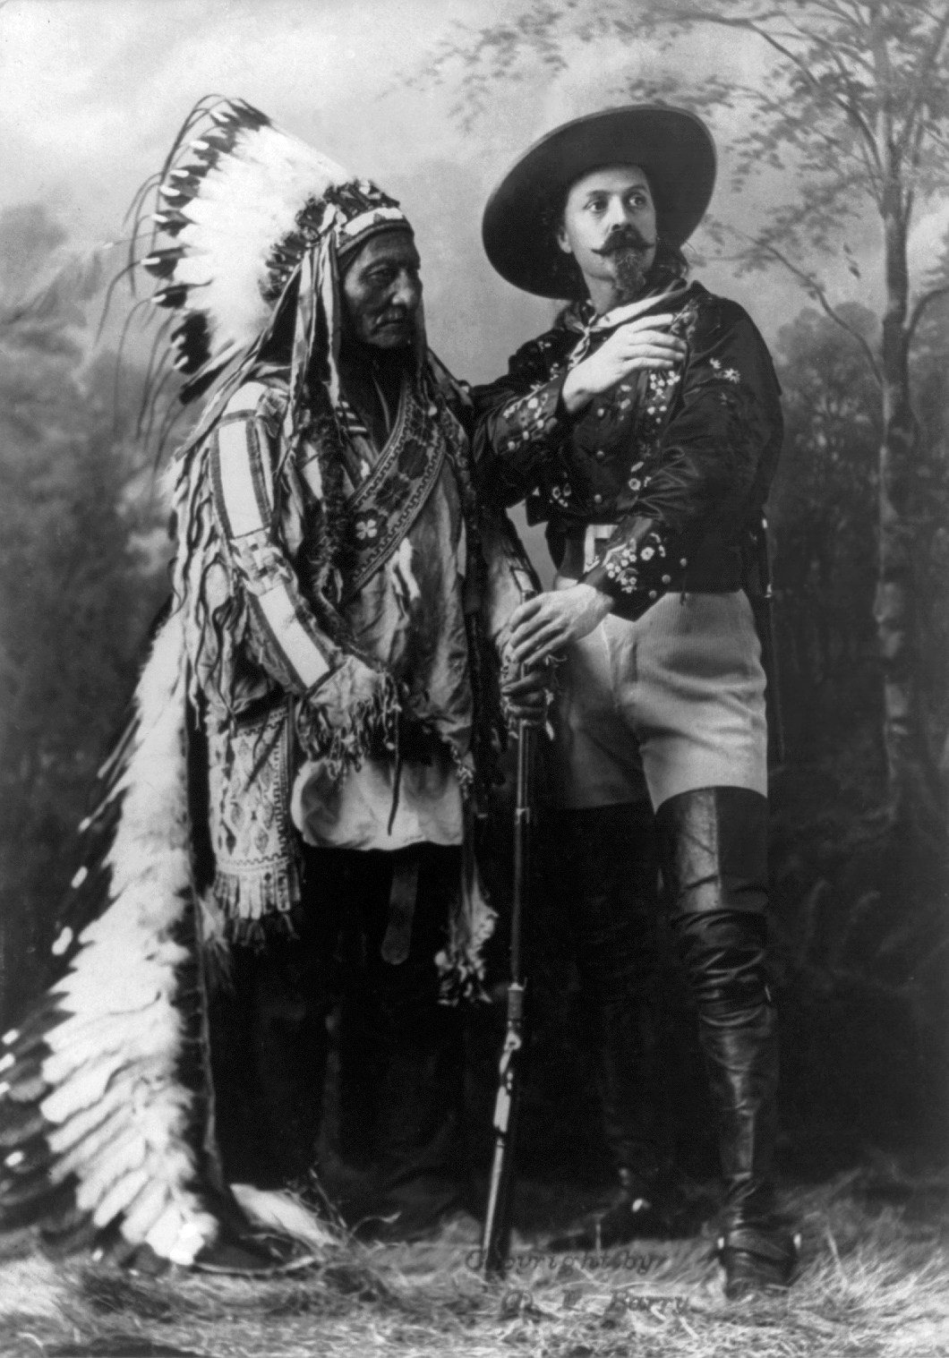  Sitting Bull toured the U.S. and Canada with William F. Cody’s Wild West Show from 1885 to 1887.
had, Buffalo Bill Cody and others were helping to make that impossible. With the herds depleted, life as the Sioux and the Cheyenne and the Arapaho and the Pawnee and their neighbors knew it came to an end.
On July 17, 1876, just a few weeks after Custer’s Last Stand at Little Bighorn, Buffalo Bill gave white Americans a taste of revenge against the Indians by taking the scalp of Yellow Hair, the son of a Cheyenne chief. This deed was not only a brazen act of warfare but also a canny business maneuver.
Between Indian fights, Cody had often performed in stage plays about the West. After his decisive triumph over Yellow Hair, re-enactments of the encounter became the centerpiece of a nationwide theatrical tour. The buffalo hunter and Indian fighter had become America’s most popular showman.
In 1883, Cody organized a combination circus, rodeo and traveling museum called the Wild West Show, which became an overnight sensation. In 1885, he had little trouble persuading the reservation agents to let him take Sitting Bull off their hands.
This arrangement was conducted at least partially on Sitting Bull’s terms. He asked for and received $50 a month payment and the full proceeds from posing for photographs. Other theatrical agents had used captured Indians as objects of mockery, but Cody treated Sitting Bull with dignity. Instead of leading other Indians into staged defeats, the Sioux chief rode his horse silently and alone into the arena. Although audiences hissed and booed, newspapers around the country and in Canada reported that the image of the solitary leader inspired a general sense of awe. Behind the scenes, Sitting Bull enjoyed the company of the other performers, especially the sure-shot Annie Oakley, whom he offered to adopt.
The respect that Cody showed Sitting Bull during his two years in the Wild West Show helped to forge a surprising friendship between the two former enemies. After Sitting Bull’s death, many chiefs followed his lead and took advantage of the relative freedom the Wild West Show offered.]

Sitting Bull returned to the reservation in 1887. The government was trying to force the Sioux to sell more land, so the chief took up his old cause of resistance.

Within a couple of years, the government had won again and divided the reduced reservation into six parts. Life for the Sioux grew more and more miserable. Diseases swept through the reservations like winds of death. Carrots and potatoes withered in the hard ground.

Around this same time, a new religious movement was spreading among Indian tribes all across the west. Far away in Nevada, a Paiute Indian farmer named Wovoka, was telling his people about a vision he’d had in which all the ancestors and buffalo rose from the dead, restoring the old Indian way of life forever. In a time of increasing pressure from whites, Indians listened eagerly to this message of deliverance. They began performing a dance that Wovoka said would make the vision come true.

Wovoka’s movement, which whites called the Ghost Dance, combined earlier Indian prophecies with elements of Christianity that Wovoka had picked up from missionaries and white neighbors. From the Mormons, for example, he may have borrowed the idea of sacred garments that protect the wearer from harm. Stories circulated that Wovoka himself was the new Messiah, Jesus Christ returned to save the Indian people.

[How the West was Lost (document): A writer named John L. O’Sullivan predicted in 1845 “the fulfillment of our manifest destiny to overspread the continent allotted by Providence.” He sensed, as many other Americans did, the unfolding of a divine plan for the country’s expansion. Just four years later, the discovery of gold in California turned “manifest destiny” into a stampede. Forty-niners (men seeking their fortunes in the gold fields in 1849) flocked west by the thousands. San Francisco was their boomtown. Calls for statehood came swift and loud.
With the admission of California to the Union in 1850, the western border of the U.S. leaped from Iowa and Missouri and Texas to the Pacific in a single bound. In more than just a political sense, the Indians in between were surrounded. The U.S. Senate imposed the following conditions in its treaty with the Western Shoshoni in 1863.
The telegraph and overland stage lines having been established and operated by companies under the authority of the United States through a part of the Shoshonee country, it is expressly agreed that the same may be continued without hindrance, molestation, or injury from the people of said bands….And further, it being understood that provision had been made by the government of the United States for the construction of a railway from the plains west to the Pacific ocean, it is stipulated by the said bands that the said railway or its branches may be located, constructed, and operated, and without molestation from them, through any portion of country claimed or occupied by them.
It is further agreed by the parties hereto, that the Shoshonee country may be explored and prospected for gold and silver, or other minerals; and when mines are discovered, they may be worked, and mining and agricultural settlements formed, and ranches established whenever they may be required.
***
The said bands agree that whenever the President of the United States shall deem it expedient for them to abandon the roaming life, which they now lead, and become herdsmen or agriculturalists, he is hereby authorized to make such reservations for their use as he may deem necessary within the country above described; and they do also hereby agree to remove their camps to such reservations as he may indicate, and to reside and remain therein.]

When Sitting Bull heard about the energy and excitement that the Ghost Dance was stirring among other tribes, he thought about his own desperate people. They were practically starving on government rations, and the government had told them that they could no longer supplement their diets by hunting game. The winter ahead promised to be a grim one on the carved-up Sioux reservations.

Sitting Bull felt the new religion might at least give his people something to hope for. In October 1890, he invited some Sioux from another area to come teach the Ghost Dance. The religion quickly attracted many followers with its promise of Indian victory and glory. Sioux men, women and children were soon so busy dancing in the snow that no work was getting done. Houses, schools and stores stood empty. The dancers claimed that the special shirts they wore would repel the white man’s bullets.

The whites had laws to protect their own freedom of religion, but the Ghost Dance frightened them. The religious frenzy seemed more a portent of rebellion than a broken culture’s desperate attempt to make sense of its collapsing world. Newspapers across the country fanned the flames of suspicion. In mid-November, Pres. Benjamin Harrison directed the Secretary of War to suppress “any threatened out-break among the Indians.” The Indian Bureau in Washington ordered its reservation agents to telegraph the names of suspected troublemakers. One of the names on this list was Sitting Bull’s.

Because of his celebrated history, the government knew it had to carry out Sitting Bull’s arrest with extreme caution. The general in charge enlisted the aid of Buffalo Bill Cody, who agreed to use his friendship, along with a few gifts, to coax Sitting Bull’s surrender. Cody travelled to the reservation, but at the last minute a nervous agent telegraphed the President and convinced him to cancel the plan.

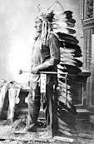  Sitting Bull hoped his own fame would call attention to the plight of his people. |  | The Ghost Dancers had been assembling in the Badlands on Pine Ridge Reservation. On December 11, Sitting Bull asked for permission to go there. Now the government believed it could justify having him arrested.  Forty-three armed reservation police surrounded his cabin before dawn on December 15. A crowd of Ghost Dancers gathered in the cold. When Sitting Bull came out, they tried to prevent his capture, but in the scuffle a policeman shot Sitting Bull through the brain.  News of Sitting Bull’s death shook the Sioux like a lightning bolt. Part of his band turned to Chief Big Foot for guidance. Big Foot was another Sioux resistance leader who had been hiding out with some supporters in the Badlands. He believed that Chief Red Cloud at Pine Ridge, who was experienced in dealing with whites, offered the
best chance for protection from the government. So he set out to take his followers there.

The refugees had little food. Many of them walked barefoot on the frozen ground, while others used torn strips of blanket to bind their feet. Sleet covered their clothes and gave them a glassy shine. Big Foot developed a deep rattling cough. He nose bled frequently, and he refused to eat. On December 15, he directed his men to kill the youngest horses and ration the meat.  When cavalry troops intercepted the party three days later, the exhausted Indians raised tattered flour sacks as truce flags. Big Foot formally surrendered and |  | 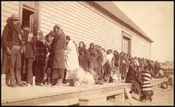  Ration day at Pine Ridge brought hundreds of Sioux women to stand in line for bacon, cornmeal, flour, coffee and sugar. In 1890, the government cut rations by 20 percent.
received an ambulance wagon to ride in. The troops then herded their captives—120 men and 230 women and children—toward the Army camp at Wounded Knee Creek. The shoes on the soldiers’ horses rang out against the earth which was hard as iron.

Although the Indians had surrendered and were clearly in no position to put up a fight, the situation at the camp was tense. Two cavalry units guarded the Sioux tepees, and Hotchkiss machine guns (with a range of two miles) sat atop a nearby rise. By morning, more guns had been added.

After a breakfast of Army rations, the Indians were ordered to give up all weapons they were hiding. A few rifles were handed over, but not enough to satisfy the officers. Soldiers herded the Sioux into a cluster and searched the tepees, collecting any knives, tools or guns they could find. They searched the women and made them unwrap their babies in the cold.

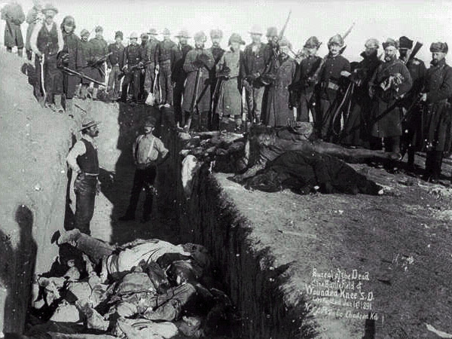  One Jan. 1 and 1, 1891, the frozen corpuses were buried in a mass grave. |  | At the edge of the crowd, a medicine man named Yellow Bird lifted his arms and started a Ghost Dance. As he danced, he sang—about strong Sioux hearts and about soldiers’ bullets falling harmless on the prairie. The people listened. Yellow Bird’s strange chant worried and angered the officers. A quick search of some Indians turned up two more rifles. An attempt to seize a third one caused it to fire.  The single gunshot set the soldiers in motion. They raised their rifles, took aim and began firing. Some of the Indians grabbed hatchets and knives from the surrendered pile. Many
fell dead. Others, including Big Foot, died where they had been sitting under blankets to keep warm. A few stray Army bullets killed soldiers. Then the hell-bursts of the Hotchkiss guns tore holes in the tepees. Thunder echoes. The blood of women and children stained the ground.

[“A Superior and Civilized Nation” (document): In 1913, members of the Pueblo tribe challenged the degree of control that Congress exercised over tribal affairs. The U.S. Supreme Court issued the following statements in its decision (United States v. Sandoval).
Always living in separate and isolated communities, adhering to primitive modes of life, largely influenced by superstition and fetishism, and chiefly governed according to crude customs inherited from their ancestors, (the Pueblos) are essentially a simple, uninformed and inferior people….As a superior and civilized nation, (the U.S. government has both) the power and the duty of exercising a fostering care and protection over all dependent Indian communities within its borders.]

Solders cried, “Remember Custer!” and kept firing. The Hotchkiss guns now fixed their aim on a ravine where some Indians hid. Most of those who fled were hunted down and shot.

When the guns went silent, the soldiers removed their own 25 dead. A blizzard that night laid a clean blanket over the corpses of 290 Sioux.

[Wounded Knee Revisited (in context)
In 1973, Pine Ridge Reservation again became a site of confrontation between Native Americans and the U.S. government. On February 27, armed members of the American Indian Movement (AIM), numbering around 200, seized control of the town of Wounded Knee.
They proclaimed themselves the “Independent Oglala Sioux Nation” and demanded that the government implement changes in tribal leadership and review all Indian treaties as well as the treatment of native peoples in general.
Federal marshals immediately surrounded the hamlet. In the nine-day siege that followed, two Oglala Sioux were killed and a federal marshal was wounded. On May 8, the government promised to negotiate on the group’s demands. AIM members surrendered their weapons and ended the standoff.
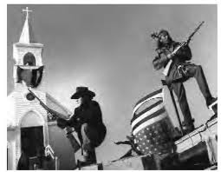  Sacred Heart Catholic Church was one of several buildings seized during the Oglala Sioux occupation of Wounded Knee in February 1973. |  | In response to this and other protests by Native Americans, Congress in 1975 passed the Indian Self-Determination and Education Assistance Act, which paid tribes to take over certain services from the federal government. Some groups, charging that the act had little substance, predicted a much longer struggle to overcome the government’s former policy of Indian “termination.”]

